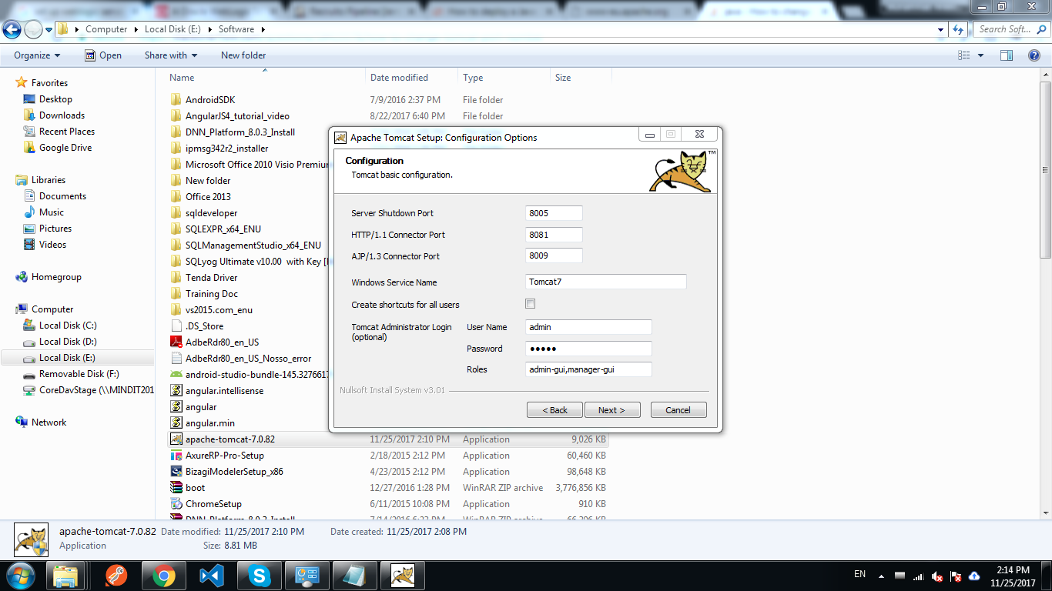

User name and password both are admin

Replace 8081 to 9090.

check this link for java directory structure:- <http://www.codejava.net/servers/tomcat/how-to-deploy-a-java-web-application-on-tomcat>